LOWER PLENTY PRIMARY SCHOOL OSH
126 Main Road, Lower Plenty 3093
Phone: 9435 2585 Fax: 9432 0844
Email: lower.plenty.ps@edumail.vic.gov.au
Website: www.lowerplentyps.vic.edu.au
CARE ● HONESTY ● ACHIEVEMENT ● RESPECT ● RESPONSIBILITY ● FUN
GOVERNANCE POLICY
PURPOSE

Our Out of School Hours Care (OSHC) Service aims to ensure all legal and financial requirements are implemented and recognised through appropriate governance practices, providing quality education and care, meeting the principles, practices and elements of the Early Years Learning Framework, My Time Our Place and the National Quality Standard.

SCOPE
This policy applies to children, families, staff, management and visitors of the OSHC Service.

DEFINITIONS
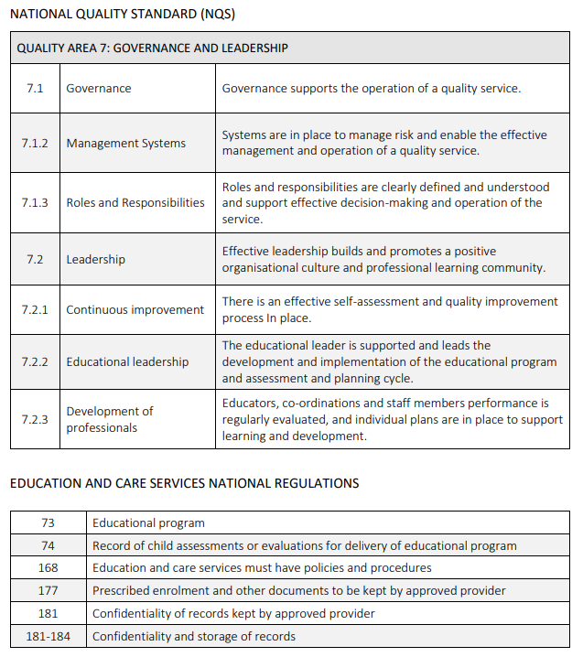

IMPLEMENTATION
Governance is the process that directs and controls our Service, ensuring accountability and supporting decision making.
The Approved Provider and Nominated Supervisor of the Service accept the legal responsibilities associated with establishing, administering, and maintaining the Service.
THE APPROVED PROVIDER IS LEGALLY RESPONSIBLE FOR:
- ensuring compliance with the Education and Care Services National Law and Education and Care Services National Regulations
- complying with Family Assistance Law.
- appointing a Nominated Supervisor, an Educational Leader and a Director/coordinator for the Service
- ensuring background checks, including criminal history and working with children checks, are completed for all staff and educators
- determining whether or not a person working in the service is a ‘fit and proper person’
- supporting the Nominated Supervisor [Responsible Persons] in their role, providing adequate resources to ensure effective administration of the Service
- developing a clear and agreed philosophy, which guides business decisions and the work of management and staff
- acting honestly and with due diligence
- ensuring there is a sound foundation of policies and procedures that complies with all legislative and regulatory requirements, and that enables the daily operation of the Service to be in line with the Service’s philosophy and goals
- maintaining up to date and current policies and procedures for compliance by all educators • confirming incident, injury, illness or trauma records are stored in a kept in a safe and secure place until the child is 25 years of age. In the event of a death of child while being cared for by the service or may have occurred as a result of an incident, the records must be kept until seven years after the death.
- being an employer, including all legal and ethical responsibilities that this entails
- appointing staff and monitoring their performance
- ensuring educator qualification requirements are current
- ensuring all educators and staff have a clear understanding of the hierarchy of management
- providing clear and direct written and verbal feedback and instruction that is suitable and appropriate to the task
- ensuring the Service remains financially viable and can meet its debts and other obligations as they fall due
- managing control and accountability systems
- reviewing the Service’s budget and monitoring financial performance and management to ensure the Service is solvent at all times and has sound financial strength
- approving annual financial statements and providing required reports to government bodies and maintaining appropriate delegations and internal controls • complying with funding agreements where appropriate
- reviewing the work process regularly
- developing coherent aims and goals that reflect the interests, values and beliefs of all stakeholders of the Service
- establishing clearly defined roles and responsibilities for the members of the Management Committee and staff, individually and as a collective, and clearly articulating the relationship between all stakeholders
- complying with all other Vic and Australian governments’ legislation that impacts upon the management and operations of a Service
THE NOMINATED SUPERVISOR IS RESPONSIBLE FOR:
- adhering to the Education and Care Services National Law and National Regulations
- developing ethical standards and a code of conduct which guide actions and decisions in a way that is consistent and reflective of the Service’s expectations
- undertaking periodical planning and risk assessments and having appropriate risk management strategies in place to manage risks faced by the Service
- ensuring that actions taken, and decisions made are clear and consistent and will help build confidence in all stakeholders
- the day to day management of the Service
- the effectiveness of the Service’s well-defined partnership between the Management Committee and the Nominated Supervisor. The partnership requires clear understanding of roles and responsibilities, and regular and open communication.
- producing outcomes together with educators and staff. Educators must agree on their responsibilities and work according to current policies and procedures.
- providing educators with training, resources and support • identifying and reporting if something significant occurs (for example: Work Health and Safety; Fraud Prevention; Complaint handling)
- identifying work required for completion and delegate to the appropriate educator/staff
- ensuring educators and staff do not delegate responsibilities for which they are accountable for or have been delegated to them by Management • delegate all tasks in writing with a clear due date
- ensuring educators are adhering to service policies and procedures.
SERVICE PHILOSOPHY
- The development and review of the philosophy and policies will be a continuous process on an annual basis or when required.
- The philosophy and associated statement of purpose will reinforce all other documentation and the practices of the Service. The philosophy will reflect the principles of the approved national framework My Time, Our Place: Framework for School Age Care in Australia.
- There will be a collaborative and consultative process to support the development and maintenance of the philosophy that will include children, parents and educators.
- All documents will be dated and include nominated review dates.
CODE OF CONDUCT
The standards of behaviour outlined in our Code of Conduct Policy provide guidance for all staff to make personal and ethical decisions related to confidentiality, recruitment, duty of care, record keeping, professional relationships and appropriate use of resources within the service.
CONFIDENTIALITY
All members of the Management Committee along with the Nominated Supervisor, Responsible Person, educators, and staff who gain access to confidential information, whether in the course of their work or otherwise, shall not disclose information to anyone unless the disclosure of such information is required by law and will respect the confidentiality of all documents and meetings that occur.
This also includes:
- using information acquired for their personal or financial benefit, or for the benefit of any other person
- permitting any unauthorised person to inspect or have access to any confidential documents or other information
- any information received or transmitted via mobile telephone (including text/SMS) or any other electronic device (e.g. email) shall be treated with the same confidentiality as any other written form of communication and must be stored confidentially. This obligation, placed on a member of the Committee of Management, Nominated Supervisor, Responsible Person, educator, and staff shall continue even after the individual has completed their term and is no longer on the Management Committee or employed by the Service. The obligation to maintain confidentiality also applies to any person who is invited to any meetings of the Management Committee.
FINANCIAL DECISION-MAKING
Our OSHC Service will make decisions which are consistent with our policies and procedures and that work in conjunction with the Education and Care Services National Law and National Regulations, our approved learning framework (MTOP), and the ethical standards within the ECA Code of Ethics.
REVIEW AND EVALUATION OF THE SERVICE
- Ongoing review and evaluation will support the continuing development of the Service. We will ensure that the evaluation involves all stakeholders.
- The development of a Quality Improvement Plan (QIP) will form part of the reflection procedure. Reflection on what works within the Service and what needs additional development will be included in the QIP.
MAINTENANCE OF RECORDS
- The Service will adhere to record keeping requirements outlined in the National Regulations (177).
- The Service will adhere to the storage of confidential records outlined in the National Regulations (181-184).
- The Service has a responsibility to keep sufficient records about staff, families, and children in order to operate dependably and lawfully.
- The Service will safeguard the interests of all children, their families, and the staff, using procedures to ensure appropriate privacy and confidentiality practices are upheld.
- The Approved Provider assists in determining the process, storage location, and time line for storage of records, using the National Regulations as a minimum standard.
- The Service's orientation and induction processes will include the provision of significant information to managers, educators, children, and families to comply with National Regulations and Standards. \The Approved Provider will ensure that the record retention procedure meets the requirements of the following government departments:
- Australian Tax Office (ATO)
- Family Assistance Office (FAO)
- Family Assistance Law
- National Law and Regulations
MANAGING CONFLCTS OF INTEREST
- Conflict of interest, whether actual, potential or perceived, must be declared by all members of the Management Committee/Nominated Supervisor and managed effectively to ensure integrity.
- Every stakeholder that is in a position of management has a responsibility to ensure their transactions, external business interests and relationships will not cause potential conflicts and to make such disclosures in a timely manner as they arise.
- The following process will be followed to manage any conflicts of interest:
- Whenever there is a conflict of interest, the member concerned must notify the Approved Provider about the conflict.
- The member with a conflict of interest must not be present during the meeting of the Management Committee or Management meeting where the matter is being discussed or participate in any decisions made on that matter. The member concerned must provide the committee / Licensee with any and all relevant information they possess on the particular matter.
- The minutes of the meeting must reflect that the conflict of interest was disclosed, and appropriate processes followed to manage the conflict.
- A Conflict of interest disclosure statement must be completed by each member of the Management Committee / staff member upon his or her appointment and annually thereafter. If the information in this statement changes during the year, the member shall disclose the change to the Approved Provider/ and revise the disclosure statement accordingly.
FURTHER INFORMATION AND RESOURCES
- Australian Children’s Education & Care Quality Authority. (2014).
- FDC Guidance Record keeping in Family Day Care Services https://www.acecqa.gov.au/sites/default/files/2018-03/FDC_RecordKeeping.pdf
- Australian Children’s Education & Care Quality Authority. Compliance Guide Approved Provider (2017) https://www.acecqa.gov.au/sites/default/files/2019-06/FDC-ComplianceGuide-ApprovedProvider.pdf
- Australian Government. Department of Education. Child Care Provider Handbook. (2019). https://www.education.gov.au/child-care-provider-handbook-0
- Early Learning Association Australia (ELLA) Employee management and development kit (2014) https://elaa.org.au/resources/free-resources/employee-management-development-kit/
- Early Childhood Australia Code of Ethics. (2016).
- Education and Care Services National Law Act 2010. (Amended 2018).
- Education and Care Services National Regulations. (2011)
- Guide to the Education and Care Services National Law and the Education and Care Services National Regulations. (2017).
- Guide to the National Quality Framework. (2018). (Amended 2020).
- Revised National Quality Standards. (2018)
- Work Health and Safety Act 2011 (Cth)
REVIEW CYCLE AND EVALUATION
This policy was last updated on 20th January, 2022 and is scheduled for review in January 2025.

